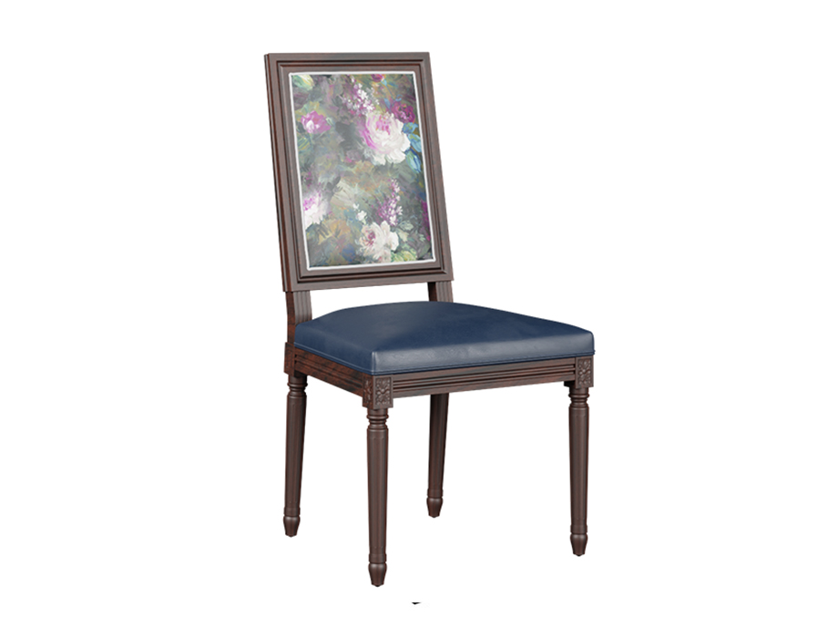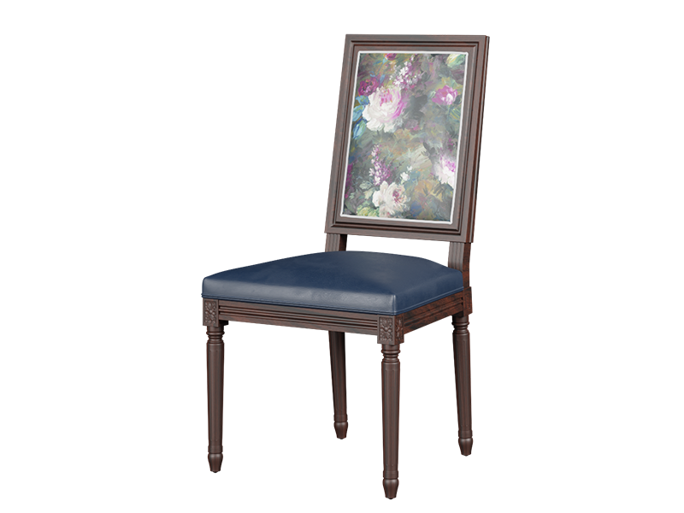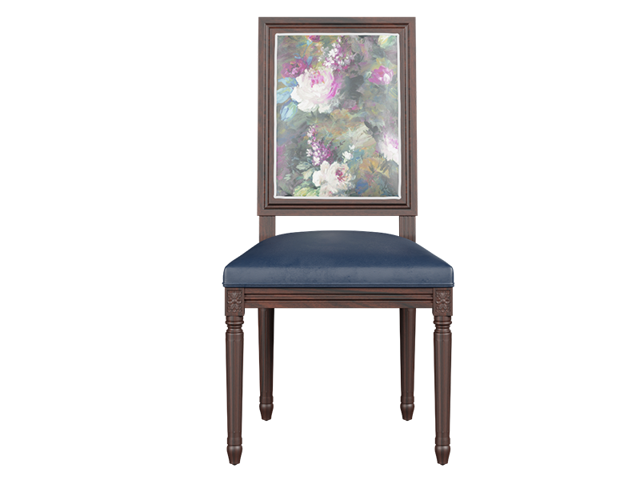

Antico Dining Chair in Floral Printed Fabric

PKR 23,738PKR 28,600

Design:

[Antico Sienna](https://interwood.pk/antico-sienna-dining-set.html)

Delivered in :15 - 20 Working Days

* Chair Back Printed in Floral Fabric
* Seat in Leatherette
* The structure is in Mahogany Wood
* Smoked Walnut Polish Finish
* Size:
  + 510 W x 570 D x 1020 H (mm)
  + 20 W x 22.4 D x 40.1 H (inches)

Note: The actual colours may vary from those shown depending on the device you are using to view the product or the angle of the item is photographed.

Read Less